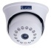
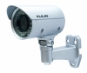
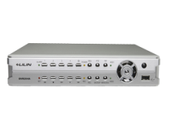
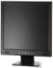
Indoor Camera Outdoor Camera DVR / NVR Monitor

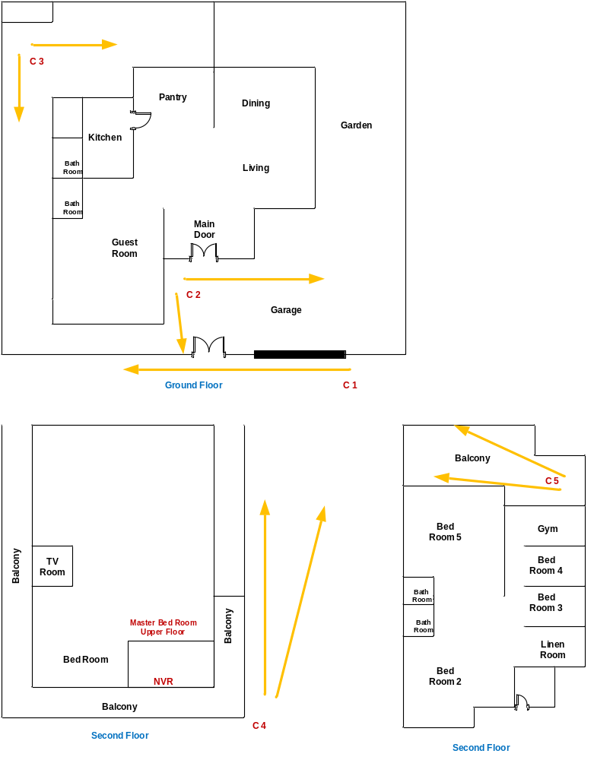

Customer Name | Vidya Jyothi Prof. Rohan W Jayasekara
Drawing Title | CCTV
Issue No | RE/TE
Issue Date | 28/9/2018
Revision No
Revision Date | 4/10/2018
Created By | Ajith Fernando
Approved By

